CALL FOR PARTNERS FOR YOUTH INICIATIVES
Rural Art, what can you do together?

Date of the activity in the promoter country: 20th April 2011 to 3rd May 2011
Place: Vimioso, Portugal
Deadline for applications: 29th October 2010
Contact person and e-mail for applications: Miguel Nóvoa, burrranco@gmail.com
Participants: From each organisation, 5 participants (above 18 years-old)

Brief description of the association: The promoter association AEPGA (Associação para o Estudo e Protecção do Gado Asinino) works for the conservation and genetic improvement of the Miranda donkey breed. The AEPGA promotes and collaborates in the spreading of the Miranda donkey breed, giving technical support to the owners of the Miranda donkey and finds new uses for the animal, since most of these animals are no longer used in the fields. The association is also trying to revitalize some of the old cultural events, such as fairs where the donkey were of major importance.
Besides its daily duties (such as taking care about donkeys, all the activities of promotion and valorization of the donkeys, divulgation of the events, projects proposals), AEPGA already organized some events, with the purpose of promote the new uses of donkeys, as the ecoturism, or the the Annual Meeting of Asinotherapy (a set off activities that aim to overcame physical, social, emotional, cognitive handicaps) and also has been working along with the people of the villages to their traditions.

More info in www.aepga.pt

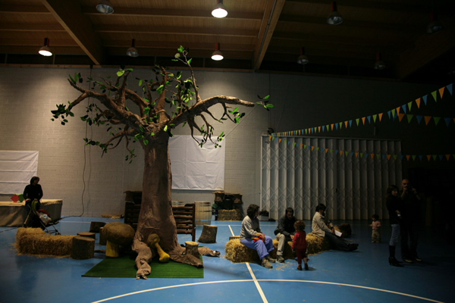 | 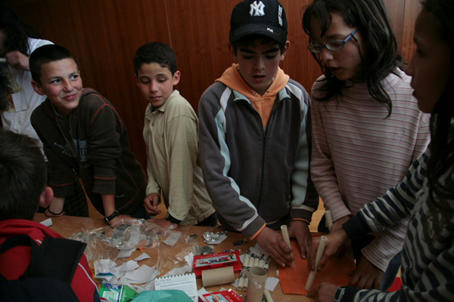
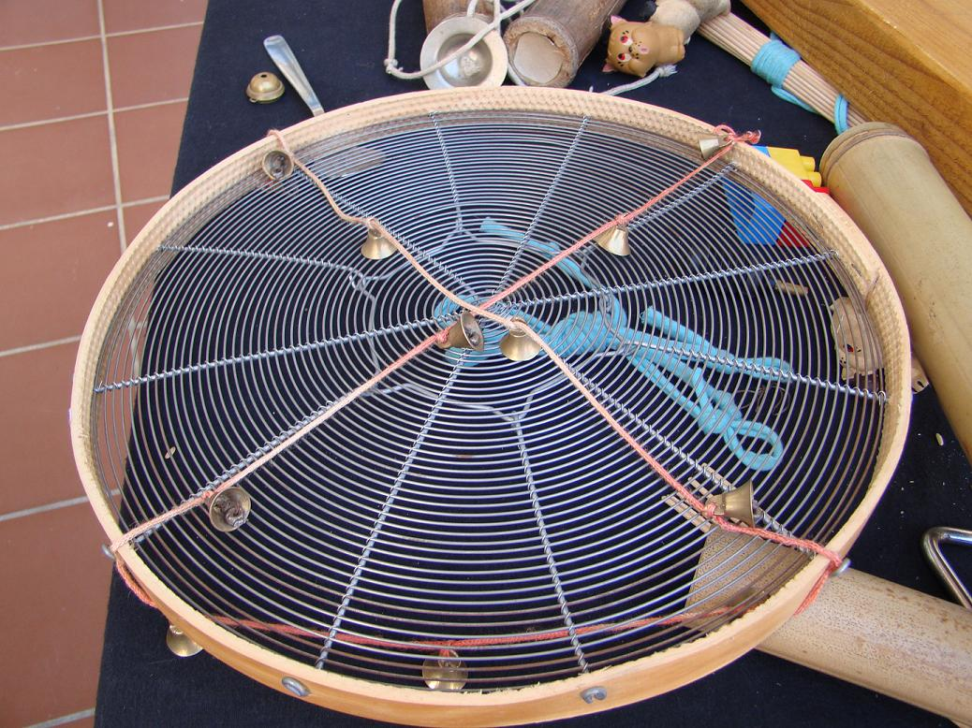  Ilustração 2 –Festival Sons e Ruralidades | 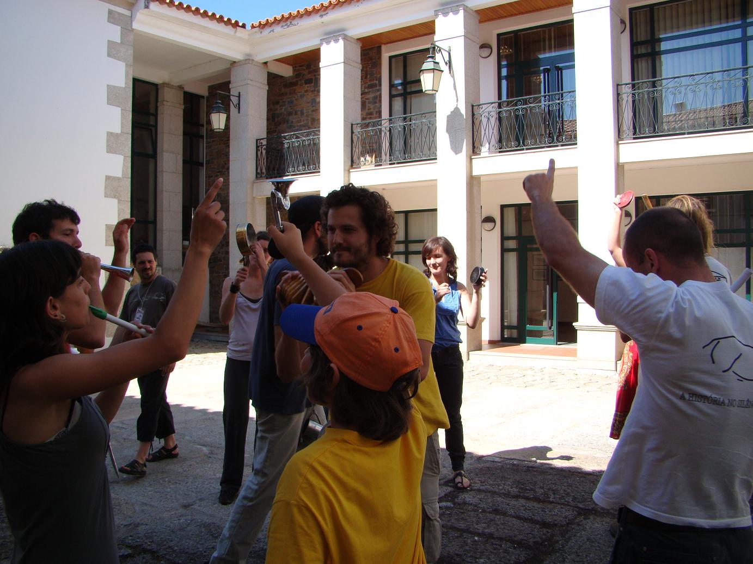

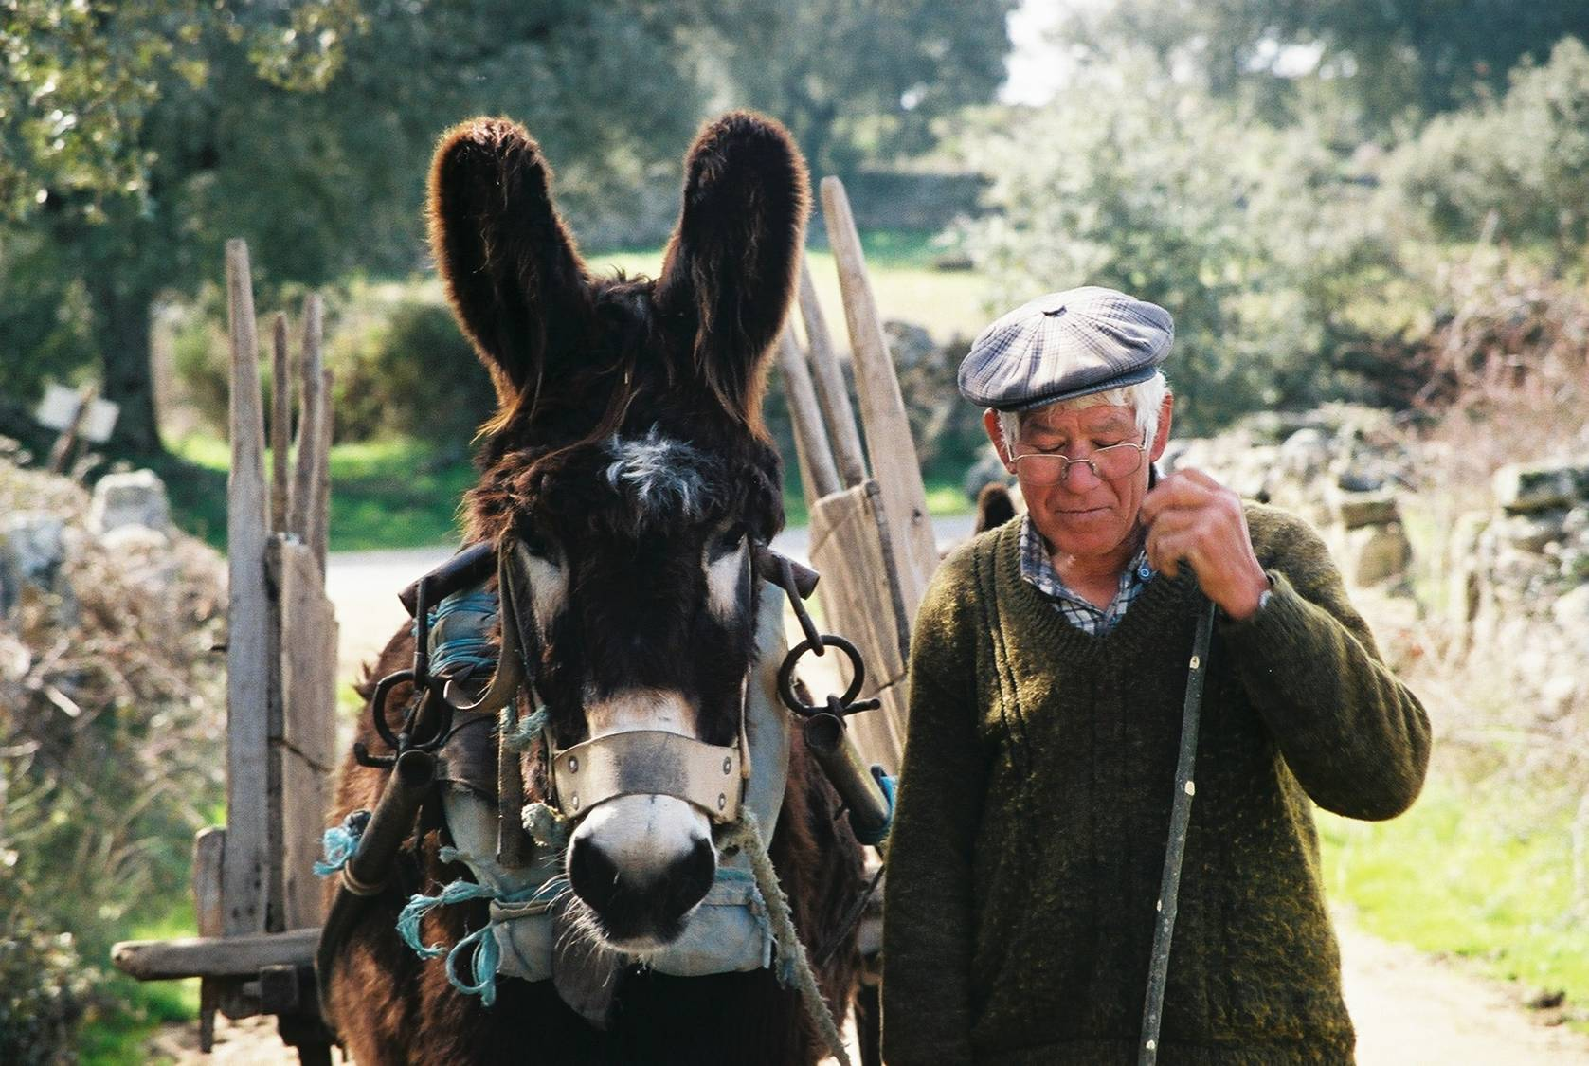
Ilustração 1 – Miranda Donkey

Brief description: The Project Rural Art, what can you do together? is one of the possible reflections on the subjects of Biodiversity and the european Rural world, and the profound relation that exists between the rural communities and the positive maintenance of endangered floristic and faunistic agents in such environments.
Its main objectives are the awakening of a european environmental-sustainable mentality, where different european citizens can interact and share their points of view on the intrinsic, permeable and ancestral link between Humanity and Biodiversity, and the “bridges” we can inforce and potenciate, as european non-profit organizations to promote it.

AEPGA pretends to develop a project that will consist of the gathering of a group of European associations that develop their work in different areas: Theatre, Dance, Sculpture (specially Land art), Cinema, Heritage, Environment, Gastronomy, Astronomy, among others.
The Activity in Vimioso, Portugal, will have the duration of about two weeks. During that time, the members of the different associations would be invited to create/develop a performance/object of art to present to the audience in the last days of the Activity, during the 6th edition of the Festival Sons & Ruralidades, which allies rural tradition to different forms of art (http://www.youtube.com/watch?v=7geYY2habYI&feature=related).
We intend this performance to result of an integrated and common effort between the European participants, around a common theme: the interpretation of the diversity of the rural world.

Practical info:
Participants will cover only 30% of their travel costs. No participation fee.
The accommodation and food is covered by the promoter association PALOMBAR.

Profile of participants:
Non-profit organizations of Environment and Rural Development that are able to give workshops and elaborate presentations.

If you would like to take part in this Youth Iniciative, please write a short description of ideas and activities that your organisation would like to present
and send it with Part III to
burranco@gmail.com

